**Herguan University**

**Project Schedule & Cost Control - Fall 2015**

**Course Number:** PJM 530

**Student Id:** 141003

**Student Name:** Akashdeep Batra

**Using Microsoft Project do the following project schedule and then answer the questions that follow**

* Create a project for developing a website with the following phases
  + Requirements
  + Analysis
  + Development
  + Testing
* Onboard your team
  + Messi (BA) Rate 100 $/hr
  + Rocky (Dev) Rate 125 $/hr + Overtime rate 150$/hr
  + Kate (QA) Rate 80 $/hr
* Create two tasks under each phase and assign resources appropriately
  + For requirements
    - BRD Authoring (Messi – 100%) – 2 weeks
    - BRD Review (Messi – 50%, Rocky 50%) – 3 days
  + Analysis
    - FSD authoring (Messi – 100%) – 2 weeks
    - FSD Review (Messi – 50%, Rocky 50%) – 5 days
  + Development
    - Developing the website (Rocky 100%, Messi 25%) – 5 weeks
    - Unit Testing (Rocky 100%, Messi 25%) – 2 weeks
  + Testing
    - Test case authoring (Kate 100%) – 1 week
    - Test case execution (Kate 75%, Messi 25%, Rocky 75%) – 4 weeks
* Dependencies
  + BRD Review can start half way when Authoring is done
  + FSD Authoring can start in paralles to BRD review
  + Development has to start after analysis is completed
  + Test case authoring can start after BRD review is completed
  + Test case execution has to start after unit testing is completed

1. **Develop the project schedule showing dependencies:** The relationships between the tasks are called dependencies. In Microsoft Office Project, we can create dependencies between tasks in the same project, and between tasks in different projects. Project offers four kinds of task dependencies:

* Finish-to-start
* Start-to-start
* Finish-to-finish
* Start-to-finish

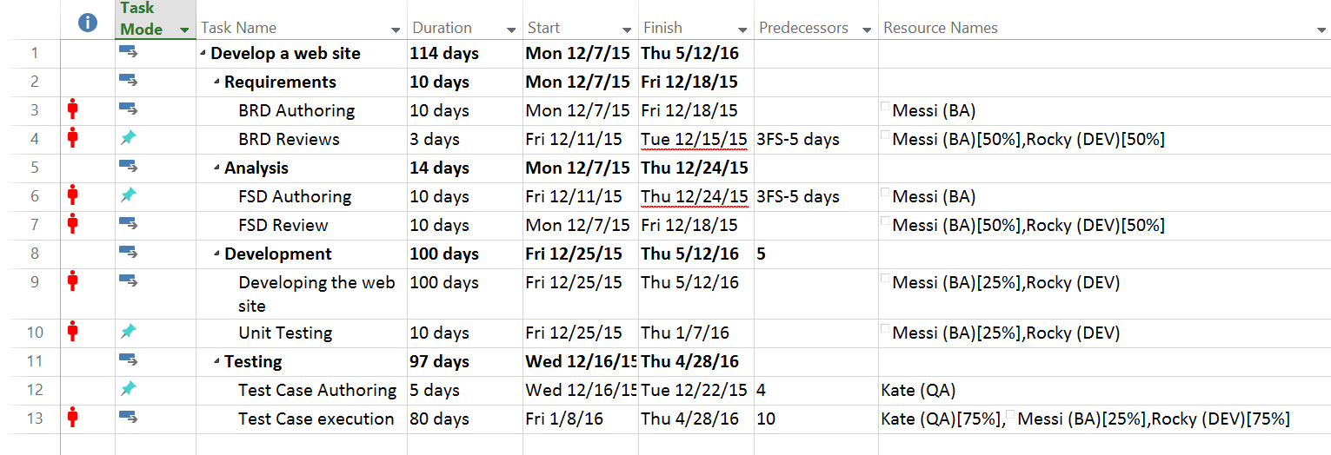

1. **Gantt Chart:** It lists the tasks in your **project**, and illustrates their relationship to one another and the schedule using **Gantt** bars.

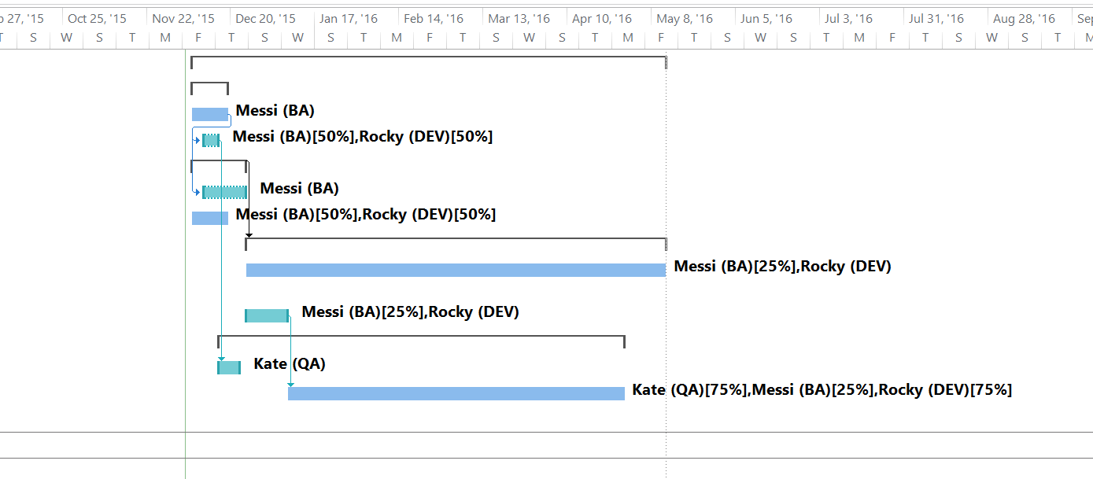

1. **Critical path:** The critical path is the series of tasks that dictates the calculated start date or finish date of the project. If a single task is late on the critical path, the end date of the entire project will also be late.

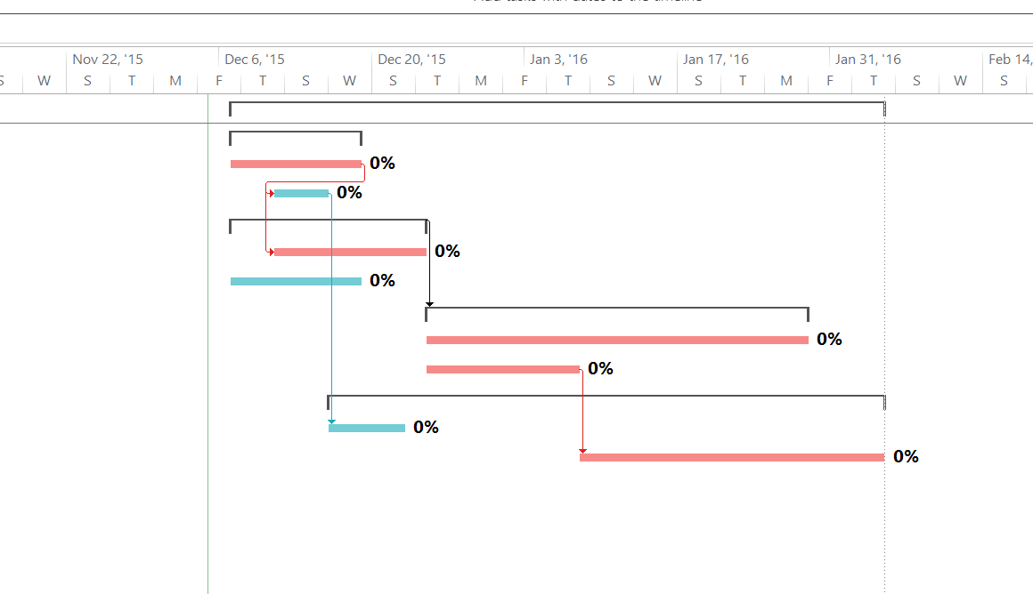

1. **Resource Leveling:** A technique in which start and finish dates are adjusted based on resource constraints with the goal of balancing demand for resources with the available supply

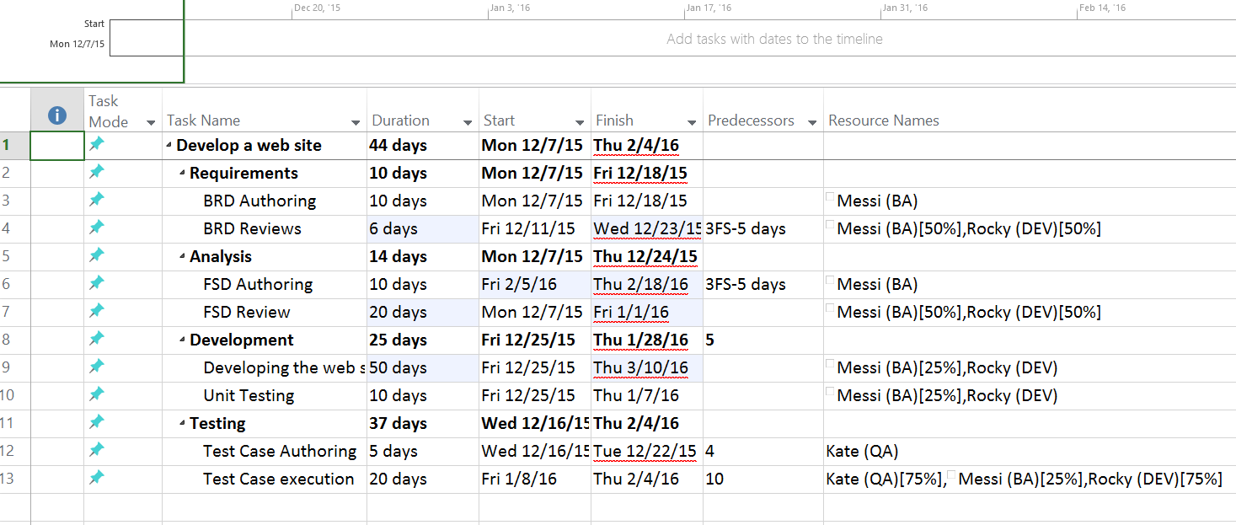

1. **Setting project baseline:** A baseline is a fixed schedule, which represents the standard that is used to measure the performance of the project.

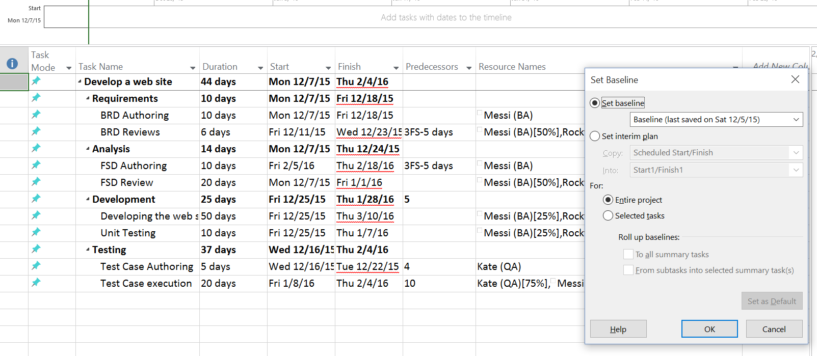

1. **Earned value cost indicators:** Cost indicators show the difference between the earned value and the actual cost

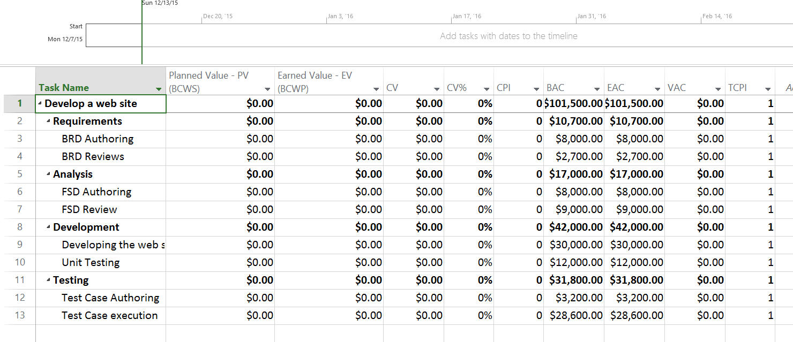

1. **Earned value schedule indicators:** Schedule indicators show the difference between the earned value and the planned value

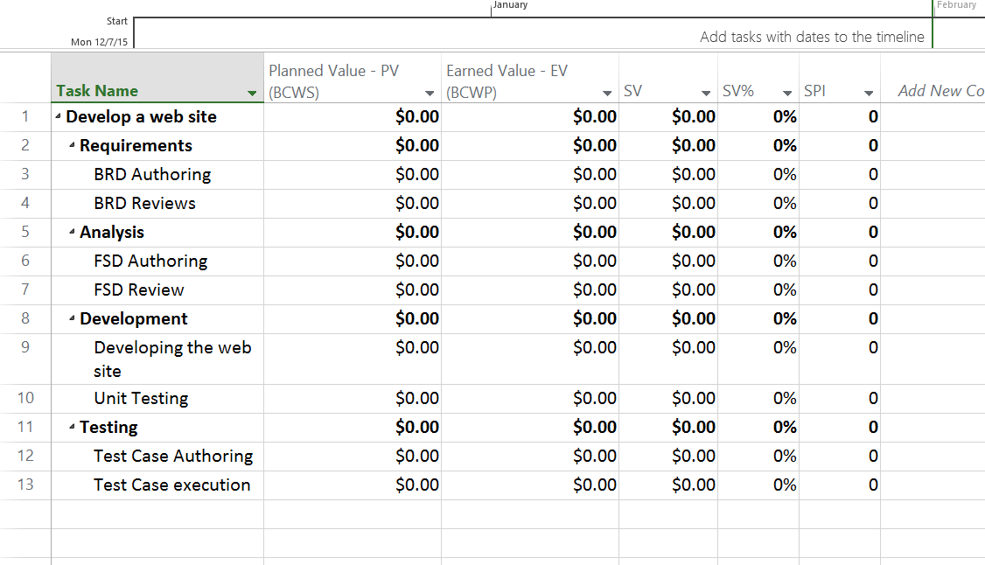

1. **Showing slack in the Gantt chart:** Slack is the amount of time that a task in a project can be delayed without causing a delay to the subsequent tasks project completion date

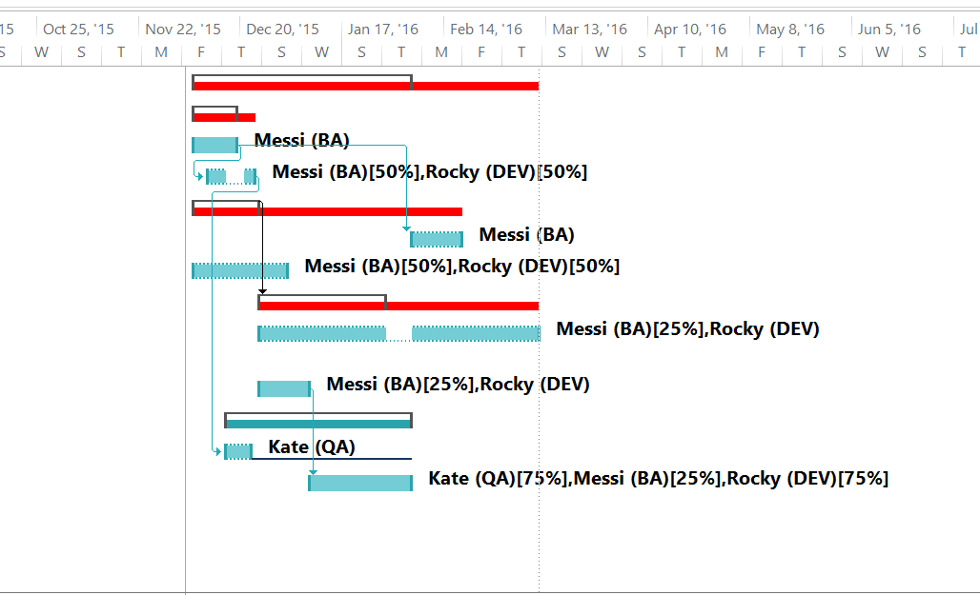

1. **Add a milestone:** A milestone is a reference point that marks a major event in a project and is used to monitor the project's progress.

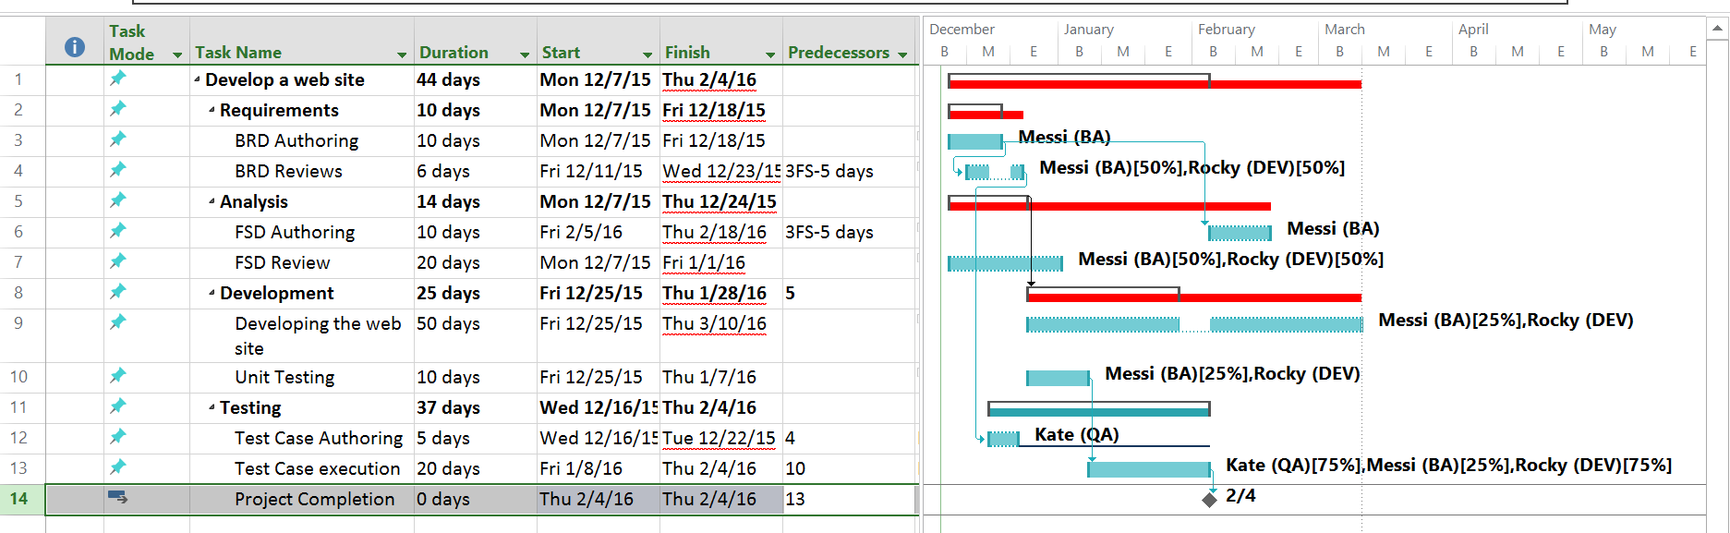

1. **Demonstrate a custom report to show resource usage (optional)**

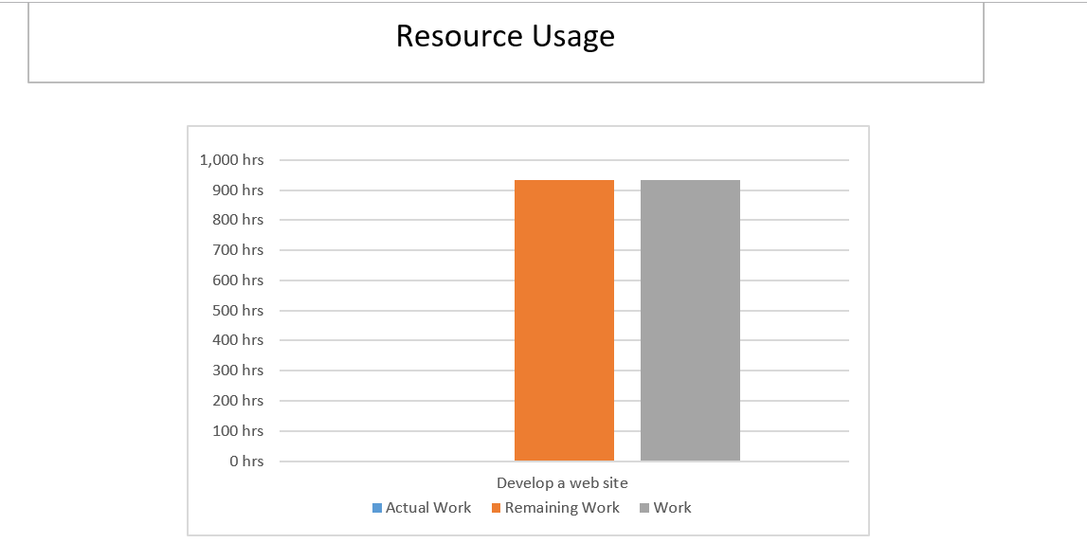

1. **Timeline to copy into a presentation**

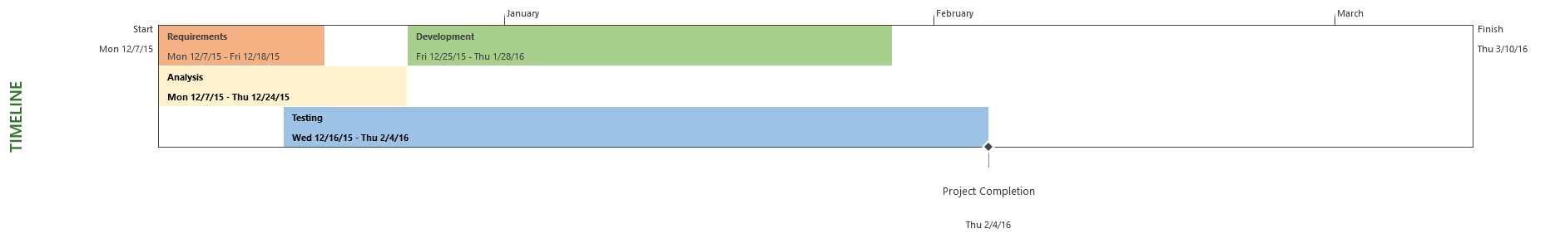

1. **Calculate Budget**

**BAC:** Planned Budget

**EAC**: Estimated Budget

